**UNIT 2**

**Difference Between AC & DC Bridge**

One of the significant difference between the AC and DC bridge is that the AC bridge is used for measuring the unknown impedance of the circuit whereas the DC bridge is used for measuring the unknown resistance of the circuit. The other differences between the AC and DC bridge are shown below in the comparison chart.

Comparison Chart

| **Basis for Comparison** | **AC Bridge** | **DC Bridge** |
| --- | --- | --- |
| Definition | The bridge which is used for measuring the value of unknown impedance is known as the AC bridge. | The DC bridge measures the unknown resistance of the circuit. |
| Supply | AC supply is used | DC supply is used |
| Current Detector | AC Detector | DC Detector |
| Components | Resistive and Reactive | Resistive |
| Wagner’s Earthing Device | Required | Not required |
| Types | Two | Seven |
| Balancing Time | Relatively Less | High |

Definition of AC Bridge

The ac bridge consists source, balanced detector, and the four arms. The arms of the bridge consist the impedance. The AC bridge is constructed by replacing the battery with the ac source. The bridges are formed by replacing the DC battery with the AC source and galvanometer with the [Wheatstone bridge](https://circuitglobe.com/wheatstone-bridge.html). The bridge is used for detecting the [inductance](https://circuitglobe.com/what-is-a-inductance.html), [capacitance](https://circuitglobe.com/what-is-a-capacitance.html), storage factor, dissipation factor etc.

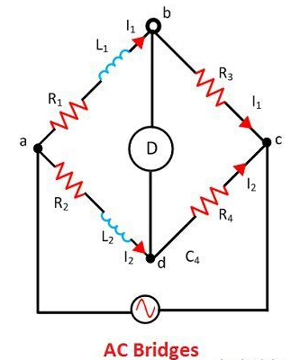

Definition of DC Bridge

The DC Bridge is used for measuring the unknown electrical resistance. This can be done by balancing the two legs of the bridge circuit. The value of one of the arm is known while the other of them is unknown.

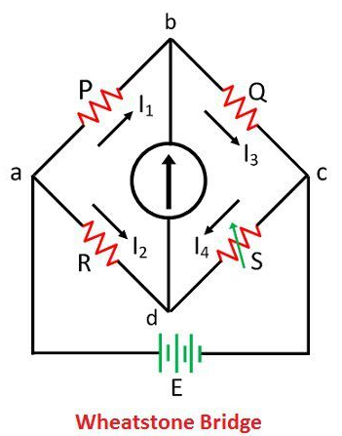

Key Differences Between AC and DC Bridge

1. The bridge which is used for measuring the unknown impedance of the circuit is known as the Wheatstone bridge. The DC bridge is used for measuring the unknown resistance of the circuit.
2. The AC bridge uses the AC supply. The DC bridge uses the DC supply for measuring the resistance.
3. In AC bridge the current is detected by using the AC detector. While in DC bridge the current is detected by using the DC detector.
4. The resistive and reactive components are used in the AC bridge circuit while in the DC circuit only resistive components are used.
5. The AC bridge circuit uses the Wagner earth device for removing the earth capacitance from the circuit. It also reduces the harmonics and the error which occurs because of the stray magnetic field. The [Wagner earthing device](https://circuitglobe.com/wagner-earthing-device.html) is not used in the DC bridge circuit.
6. The AC bridges take less time to comes in balance condition while the DC bridge uses comparatively more time to comes in the balanced condition.
7. Wheatstone Bridge and the Kelvin bridge are the types of the DC bridge. The AC bridges are classified into seven types. These are capacitance comparison bridge, inductance comparison bridge, [Maxwell’s bridge](https://circuitglobe.com/maxwells-bridge.html), [Hay’s bridge](https://circuitglobe.com/hays-bridge.html), [Anderson Bridge](https://circuitglobe.com/andersons-bridge.html), [Schering bridge](https://circuitglobe.com/schering-bridge.html), [Wein bridge](https://circuitglobe.com/wiens-bridge.html).

Conclusion

The AC and DC bridge both are used for measuring the unknown parameter of the circuit. The AC bridge measures the unknown impedance of the circuit. The DC bridge measures the unknown resistance of the circuit.

**AC Bridges - Definition, Construction, Balance Equation & Errors**

The AC Bridges are the alternating current electrical circuits used to find or measure the unknown resistance, inductance, and capacitance. These are basically measuring instruments similar to DC Bridges (e.g. Wheatstone bridge, Kelvin's bridge, etc) and only works with ac supply.

The principle of operation is based on the comparison measurement method i.e., comparing the unknown value to be determined with the known value when the bridge circuit is balanced.

Construction of AC Bridge :

The ac bridge mainly consists of four arms with four impedances (each arm consists of an impedance) and a balance detector. The four arms are connected in such a way that, it forms a closed circuit with four junctions. In the four impedances of the bridge, one of them is unknown (which is to be determined) and the remaining are known impedances. The below shows the general ac bridge circuit.

[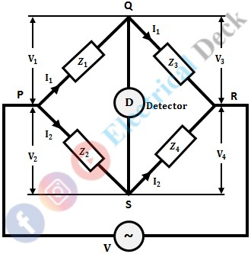](https://1.bp.blogspot.com/-s7Yp9PMQFl4/YL3JUoYnGQI/AAAAAAAADzM/93y_GXuSFpA6v9DosN6EByqmza5cRo8ewCLcBGAsYHQ/s0/ACB%2B-%2Bac%2Bbridges%2B-%2B1.jpg)

An ac voltage source at the required frequency is connected across two opposite junctions and a balance detector across the other two opposite junctions. The balance detector used is headphones or vibration galvanometers depending upon the frequency of the supply.

Mostly vibrational galvanometers are used for balance detectors in ac bridges. Because vibrational galvanometers are tuned detectors i.e., they respond only to the fundamental frequency for which they are tuned.

In the case of ac bridges, frequency and supply waveform plays a very important role. If the input waveform is perfect and does not contain any harmonics then the balancing condition for bridges can be obtained easily. But, if the supply waveform contains any harmonics, it will be very difficult to obtain the balance condition.

Thus the variation in the frequency will once again create problems for obtaining balance condition (since the balance equation in ac bridges is a function of frequency). The above problems can be eliminated by using a vibrational galvanometer as a detector in the case of ac bridges. The vibrational galvanometer will give deflection for resonant frequency and hence will not respond to other frequencies and harmonics.

Conditions for Balancing of AC Bridge :

In order to measure unknown resistance, inductance, or capacitance connected to one arm. At first, the bridge is to be balanced. For balancing of the bridge, no current should pass through the detector. This condition is obtained when the potential difference across the detector is zero (i.e., across points Q and S). If ac source potential be V and the potential drops across Z1, Z2, Z3, and Z4 be V1, V2, V3, and V4 respectively.

Thus, at when the bridge is balanced,

*V1 = V2 ...(1)*

*V3 = V4 ...(2)*

Consider equation 2, i.e., V3 = V4,

[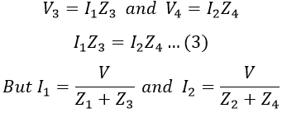](https://1.bp.blogspot.com/-3USArI8xIUc/YL3JdtAIC0I/AAAAAAAADzQ/m1wmS3DqncM1oGsjxqJHaYfNysEFBRzfQCLcBGAsYHQ/s0/ACB%2B-%2Bac%2Bbridges%2B-%2B2.PNG)

Substituting the values of I1 and I2 in equation 3, we get,

[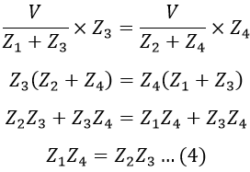](https://1.bp.blogspot.com/-3kgtdN9EYbw/YL3JjvosOrI/AAAAAAAADzU/lTdNpmpASuIf9Yut32CmPJUlkfEDscBfgCLcBGAsYHQ/s0/ACB%2B-%2Bac%2Bbridges%2B-%2B3.PNG)

We know that, Z = 1/Y. Therefore, for the balance of the bridge, equation 4 can also be written in admittance form as,

[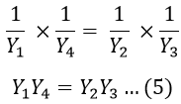](https://1.bp.blogspot.com/-6pVIAjBiIIg/YL3JoqVltbI/AAAAAAAADzc/OJM9ar-X4CcsU4EVi1_Drb_yhzhGX1x0gCLcBGAsYHQ/s0/ACB%2B-%2Bac%2Bbridges%2B-%2B4.PNG)

The equation 4 can be written in polar form as,

[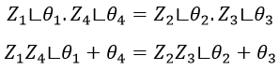](https://1.bp.blogspot.com/-YWB9xl-aU-Y/YL3JuskV4iI/AAAAAAAADzg/7DV1Gub9ZWc94FLiRZMW_eF0ORoji46KACLcBGAsYHQ/s0/ACB%2B-%2Bac%2Bbridges%2B-%2B5.PNG)

Similarly, equation 5 can be written in polar form as,

[AC Bridges](https://1.bp.blogspot.com/-zXqPNXSp3gg/YL3JzG9MrxI/AAAAAAAADzo/iSvsRsv4GEEprk8Lg6SABISiqTiM56C_QCLcBGAsYHQ/s0/ACB%2B-%2Bac%2Bbridges%2B-%2B6.PNG)

Therefore, from the above equation, the conditions for balancing ac bridges are,

* The magnitude of impedance or admittances should satisfy the relation.

*Z1 Z4 = Z2 Z3*

* The phase angles of impedances or admittances should satisfy the relation.

*θ1 θ4 = θ2 θ3*

Measurement of Resistance, Inductance, and Capacitance Using AC Bridge :

Let us consider an ac bridge with four arms and a detector as shown below.

[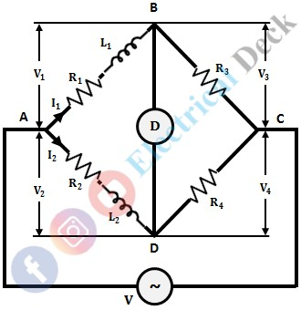](https://1.bp.blogspot.com/-PB6yS8m236Q/YL3SAoJI9kI/AAAAAAAAD0Q/9QMeVRg2I_Q-sUq_Hhz6QBatndM_V-8UgCLcBGAsYHQ/s0/ACB%2B-%2Bac%2Bbridges%2B-%2B7.jpg)

Let,

* L1 = Unknown inductance to be measured
* R1 = Internal resistance of the unknown inductor
* L2 = Standard known inductance
* R2, R3 & R4 = Standard non-inductive resistances.

From the balance condition of the bridge, we know that,

[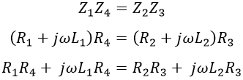](https://1.bp.blogspot.com/-xcqFJQKNsxE/YL3KRh2If2I/AAAAAAAADz4/tkxbXQJBQZACSLww6XAs1qLm7mgZF_JQACLcBGAsYHQ/s0/ACB%2B-%2Bac%2Bbridges%2B-%2B8.PNG)

Equating real and imaginary parts on both sides, we get,

[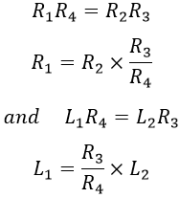](https://1.bp.blogspot.com/-J493XdHD-HI/YL3KWiIxbsI/AAAAAAAADz8/oGD_064dwPY5r1bhiJ6MbdzWkLr_prlWQCLcBGAsYHQ/s0/ACB%2B-%2Bac%2Bbridges%2B-%2B9.PNG)

Hence both the values of R1 and L1 depend upon the ratio of R3 and R4 (i.e., R3/R4). So, if we choose R3 and R4 as variable elements, then to obtain balance once R3 is adjusted then R4 is adjusted and again R3 is adjusted till the bridge comes nearer to balance then R4 is adjusted.

In this way, the balance point shifts or slides with the number of adjustments of R3 and R4. This is termed has sliding balance. Hence, if we choose R3 and R4 as variable elements then the two balancing equations will be dependent and convergence of balance becomes very poor and thus the sliding balance effect appears.

So, in order to satisfy both the balance equations and for convenience of manipulation only one element is chosen as the variable for one balance equation. So that the two balance equations are independent of each other. As R2 and L2 appear in different balance equations, they can be selected as variable elements.

Thus L2 and R2 are varied alternatively till the balance is obtained. By this, the condition of interaction between two controls is avoided. Also, the convergence to balance point is best as both R2 and L2 are in the same arm.

Errors in AC Bridges :

The different sources of errors in AC bridges are,

Stray Conductance Effects :

If there is no proper insulation between various components of a bridge circuit, errors may arise because of leakage currents from one arm to another. This mainly happens for a high impedance bridge. To overcome this variable components and other pieces of apparatus are mounted on an insulating stand.

Eddy Current Errors :

The induced eddy currents in the standard resistors and inductors change the standard values of the bridge, causing errors. To avoid such errors. The materials with large conductivity masses should not be placed near the bridge.

Errors due to Electrostatic Coupling :

The Inter-capacitance effect arises if the adjacent branches of a bridge network are at a different potential. In other words, the electric field of the branches interacts thus introducing errors. Effective shielding by means of covering elements with earthed metallic shields can minimize this error.

Errors due to Electromagnetic Coupling :

If there is electromagnetic coupling between the source and detector, an emf is induced in the detector directly from the source. The zero indication of the detector is obtained only when the bridge supplies the voltage which is equal in magnitude and opposite in phase as that of induced emf.

Residual Errors :

Residues mean small inherent inductance or capacitance that are used in bridge circuits and are assumed to be non-inductive and non-capacitive but in practice, their inductance and capacitance are never zero. So, it is necessary to evaluate these components otherwise these errors will creep in.

Frequency Errors :

The frequency of the supply system plays a vital role in causing errors in the supply system i.e., the presence of harmonics in supply causes variations in the sinusoidal waveform due to which the appreciable crosses are generated.

**Objective: Measurement of Self-Inductance by Maxwell's Bridge.**  
    In this bridge, an inductance is measured by comparison with a standard variable capacitance. The connection is shown in Figure 1.

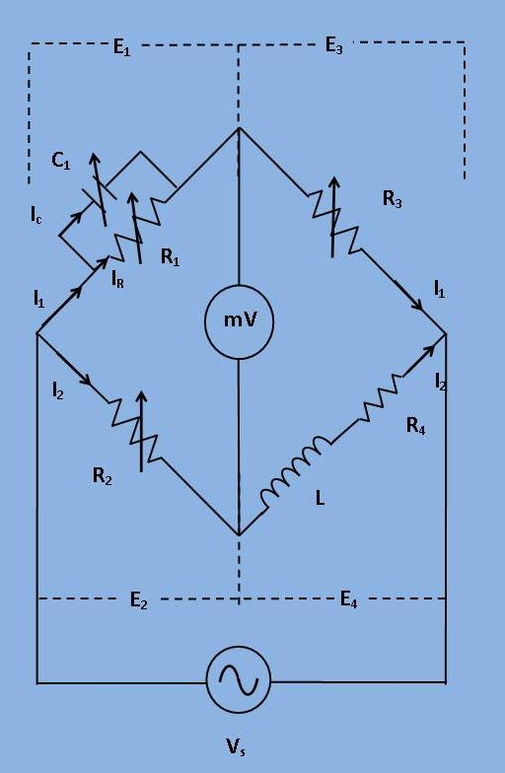

[Fig 1: Circuit diagram for Maxwell's Bridge]

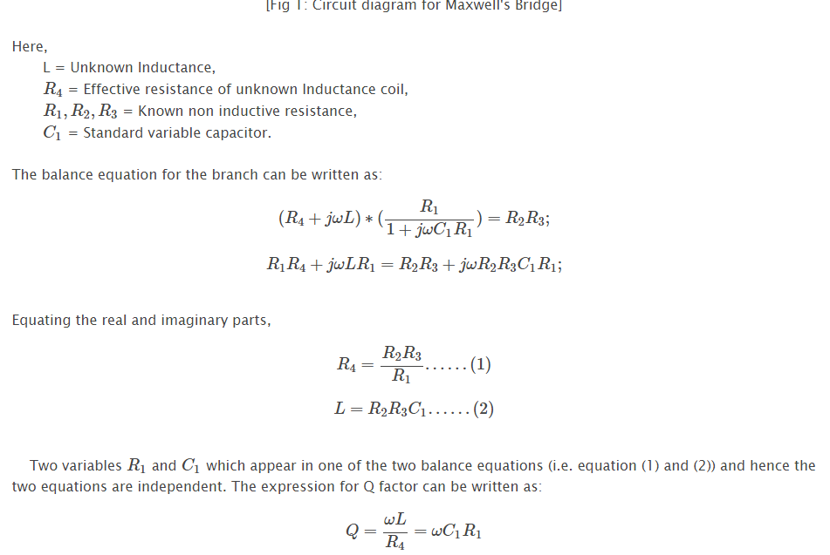

**Phasor Diagram:**

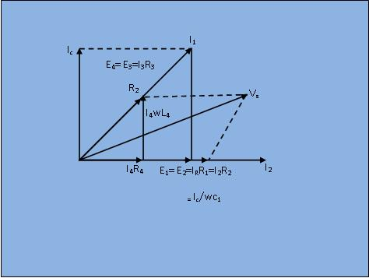

[Fig 2: Phasor diagram for the circuit shown in Figure 1]

**Hay's Bridge - Construction, Equation, Phasor Diagram & Advantages**

Hay's bridge is the electrical circuit used for the measurement of self-inductance. It is an alternating current bridge similar to Maxwell's bridge with small modifications.

The main difference between Hay's bridge and Maxwell's bridge is that Hay's bridge employs a resistance in series with the standard capacitor, whereas Maxwell's bridge uses a resistor in parallel with the standard capacitor.

Construction of Hay’s Bridge :

The Hay's bridge is a modified form of Maxwell's inductance-capacitance bridge. It measures inductance by comparing it with a standard variable capacitance. The circuit diagram of Hay's bridge is shown below.

[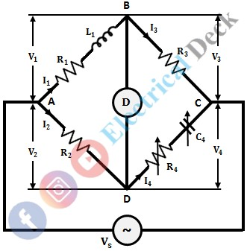](https://1.bp.blogspot.com/-pnjgMTqa8-8/YLoENb4H1LI/AAAAAAAADw8/VH-AkQbFuJIyVjNMcfljqc8Rqi3x5h-oACLcBGAsYHQ/s0/ACB%2B-%2Bhay%2527s%2Bbridge%2B-%2B1.jpg)

It consists of an inductor with an inductance L1 and internal resistance R1 in arm AB and non-inductive standard resistances R2 and R3 in arms AD and BC respectively, and a known variable standard capacitance C4 in series with known non-inductive variable standard resistance R4 in arm CD.

Operation and Theory of Hay’s Bridge :

The bridge can be balanced by adjusting the values of R4 and C4. From the above figure,

[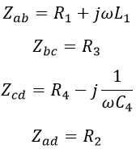](https://1.bp.blogspot.com/-F9VONEjlbDk/YLfJXG6dKJI/AAAAAAAADs0/3R-hoIsv5oEu-uGelyrPKz-PDUR7-8RWgCLcBGAsYHQ/s0/ACB%2B-%2Bhay%2527s%2Bbridge%2B-%2B2.PNG)

Under balanced condition, we have,

[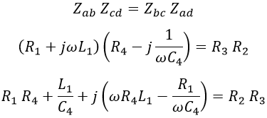](https://1.bp.blogspot.com/-nPFNUmrQB2g/YLfJjVAlurI/AAAAAAAADs8/sbsE9KH2cHci36OcDfX5kNUrKXwUjwVdQCLcBGAsYHQ/s0/ACB%2B-%2Bhay%2527s%2Bbridge%2B-%2B3.PNG)

Equating real and imaginary terms on both sides, we get,

[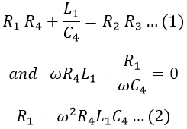](https://1.bp.blogspot.com/-iYanuQAU_vw/YLfJrFdRmLI/AAAAAAAADtE/MVJGwL3Urrcm9taTDALWuliwbdSZ9NaNQCLcBGAsYHQ/s0/ACB%2B-%2Bhay%2527s%2Bbridge%2B-%2B4.PNG)

Substituting equation 2 in 1, we get,

[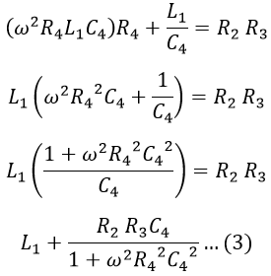](https://1.bp.blogspot.com/-58ELK-Aj6Ng/YLfJyg8LE_I/AAAAAAAADtM/INjxBJeTQEgepgMt1VkS_ZU4n7OOuIW3ACLcBGAsYHQ/s0/ACB%2B-%2Bhay%2527s%2Bbridge%2B-%2B5.PNG)

Substituting equation 3 in 2, we get,

[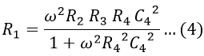](https://1.bp.blogspot.com/-bfaCWbdqGiw/YLfJ448F_1I/AAAAAAAADtQ/_x1HfxGfrggqZRA5SIESIggQFHHL-ADbgCLcBGAsYHQ/s0/ACB%2B-%2Bhay%2527s%2Bbridge%2B-%2B6.PNG)

Now, the quality factor of an inductor is given by,

[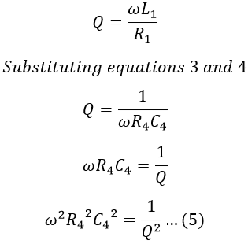](https://1.bp.blogspot.com/-Co6gtGd01_o/YLfJ-iAHwLI/AAAAAAAADtY/rkHaY9FGTL0sPXWLq3dih4SSa-NI2d1owCLcBGAsYHQ/s0/ACB%2B-%2Bhay%2527s%2Bbridge%2B-%2B7.PNG)

Substituting equation 5 in 3, we have,

[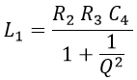](https://1.bp.blogspot.com/-D4ZpXzK5vnY/YLfKDjXTY8I/AAAAAAAADtg/QqLHgYbx6yIYK6bexx7JYltgqixgKzfQQCLcBGAsYHQ/s0/ACB%2B-%2Bhay%2527s%2Bbridge%2B-%2B8.PNG)

For high Q coils i.e., Q > 10, 1/Q2 is almost negligible. Hence the above equation reduces to,

*L1 = R2 R3 C4*

From the above equations, we can say that for high Q coils the expression for L1 is free from the frequency term. For low Q coils, 1/Q2 cannot be neglected and hence to find L1, the frequency of source is to be accurately known. Therefore, the bridge suits only for the measurements of inductance of high Q coils.

**Phasor Diagram of Hay’s Bridge :**

The below shows the phasor diagram of the bridge under balanced conditions. By taking inductor current I1 as the reference phasor. It is the current of arm AB, then the voltage drop across R1 will I1 R1 which will be in-phase with I1. Similarly, the voltage drop across L1 will be I1 ωL1 which leads the current I1 with 90°. Now the total voltage drop V1 of arm AB will be the sum of voltage drops across R1 and L1.

[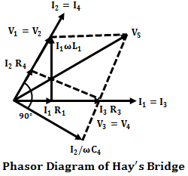](https://1.bp.blogspot.com/--PEv8F71W_I/YLfKLZDX1sI/AAAAAAAADto/_1uWhG_SEIcUQOmTpL4cZx8Gp4E74LQxACLcBGAsYHQ/s0/ACB%2B-%2Bhay%2527s%2Bbridge%2B-%2B9.png)

When the bridge is balanced, B and D will be at the same potential and there will be a null-deflection i.e., V1 = V2 and V3 = V4, also I1 = I3 and I2 = I4. Therefore, the phasor V2 lies along with V1 with equal magnitude, and the voltage drop I2 R2 (in AD arm) and current I2 will be in-phase with V2.

Also, when the bridge is balanced I4 lies along with I2 and I3 with I1. Similarly, the voltage drop along the BC arm will be I3 R3 and will be in-phase with I3. Thus I3 R3 lies along phasor I3 which is nothing but V3, and V4 will be equal to V3 under balanced condition.

Now the voltage drop in arm CD is the sum of voltage drops across capacitor and resistor i.e., I4 R4 + I4/ωC4. Due to capacitance, the drop I4/ωC4 lags behind the I4 by 90° and I4 R4 lies along with I4. Therefore, the resultant of drop I4 R4 and I4/ωC4 will be V4 (also equal to V3). The resultant of V1 and V3 will be the Vs since Vs will be equal to (V1 + V3) or (V2 + V4).

Advantages of Hay's Bridge :

* The expression obtained for the Q-factor of the coil using Hay's bridge is not a complicated one.

[Hay's Bridge](https://1.bp.blogspot.com/-tfP-iFryv4c/YLfL3KjfdhI/AAAAAAAADt8/yofbS7WG5M4itMxzWDuiKJbmp1Tkg8CPwCLcBGAsYHQ/s0/ACB%2B-%2Bhay%2527s%2Bbridge%2B-%2B10.PNG)

* From the above expression, it can be seen that the resistance R4 is inversely proportional to the Q-factor. Lower the resistance higher the Q-factor. Thus for high Q coils, the value of resistance R4 should be quite small. Hence, the bridge requires the resistance of low value.
* Hay's bridge is suitable for coils whose quality factor is greater than 10 (Q > 10). Also, it gives a simple expression for unknown inductance for high Q coils.

Disadvantages of Hay's Bridge :

The major drawback of Hay's bridge is that it cannot be used for measuring coils having a Q-factor less than 10. We have,

[](https://1.bp.blogspot.com/-ob6JmIoxCqM/YLfLuAg2QqI/AAAAAAAADt4/Od82HThcNyoxCVn4QYzD9WiJOeTUvOBWACLcBGAsYHQ/s0/ACB%2B-%2Bhay%2527s%2Bbridge%2B-%2B11.PNG)

For lower values of Q(<10) the term (1/Q)2 in the above expression cannot be neglected. Hence this bridge cannot be used for coils that have a Q-factor less than 10. For such coils, Maxwell's bridge can be used.

Objective:

Measurement the Capacitance by Schering Bridge.

Circuit Diagram:

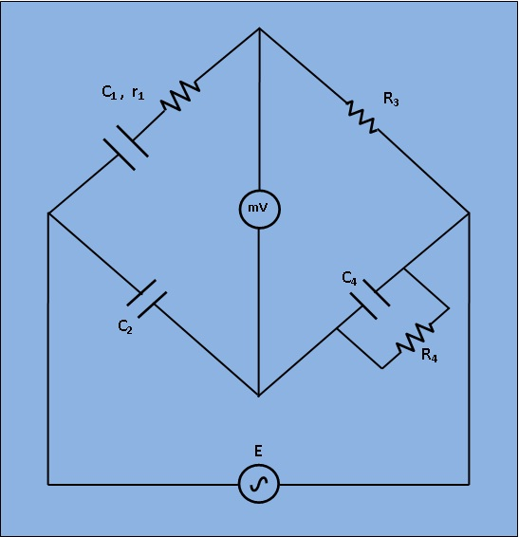  
[Fig 1: Circuit diagram for measurement of Capacitance by Schering Bridge]

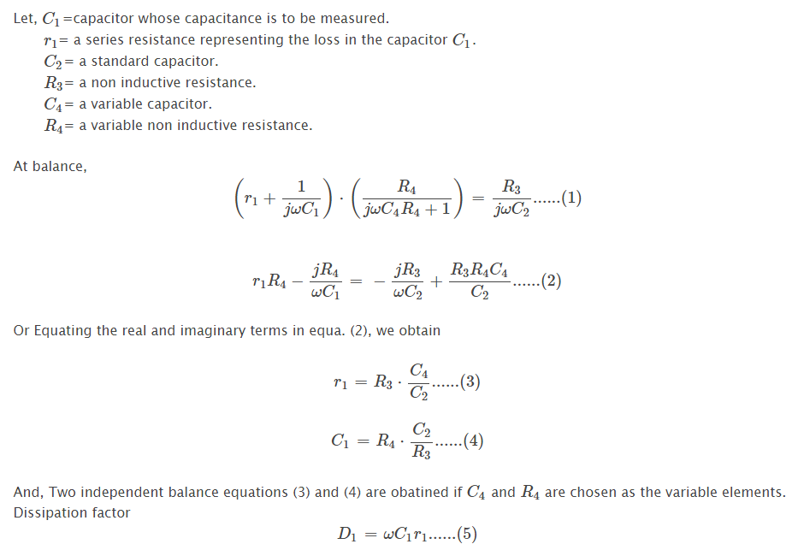

**Measurement of Low, Medium & High Resistance - Various Methods**

Resistance is one of the important parameter in electrical parameters. Thus it is essential to known the resistance of any circuit to understand the behavior of any element in the circuit. Measurement of resistance is also used for the measurement of other electrical quantities. Depending upon the value of resistance they are classified into three categories,

* Low Resistance - Resistance of the order of 1Ω and below are classified as low resistance.
* Medium Resistance - Resistance ranging from 1Ω to 100Ω are classified as medium resistances
* High Resistance - Resistance of the order of 100kΩ and above are classified as high resistances

Even though there are multimeters for the measurement of resistance. In order to obtain accurate value, suppose if the resistance is very low and very high various methods are implemented. Hence for the measurement of resistance, the above classification is done and different techniques are applied for low, medium, and high values of resistances.

Measurement of Low Resistance (<1Ω) :

The various methods that can be employed for the measurement of low resistance are,

* Ammeter-voltmeter Method
* Kelvin's Double Bridge Method
* Potentiometer Method

Ammeter-voltmeter Method :

This method is the simplest of all. It only requires an ammeter and a voltmeter which is easily available in the laboratory. However, it is not so accurate because of the voltage drop across the ammeter and the shunting effect of the voltmeter.

Kelvin's Double Bridge Method :

This method is most accurate compared to other methods. It eliminates the error, due to the contact and lead resistances.

Potentiometer Method :

It is also one of the accurate method of obtaining the value of resistance, but the accuracy of this method depends on the availability of a stable dc supply.

Measurement of Medium Resistance (1Ω to 100kΩ) :

The various methods that can be employed for the measurement of medium value resistance are,

* Ammeter-voltmeter Method
* Substitution Method
* Wheatstone Bridge Method
* Ohmmeter Method

Ammeter-voltmeter Method :

The ammeter-voltmeter method being simple can also be used for the measurement of medium resistance, but the accuracy is again less owing to the same reason as that of low resistance measurement.

Substitution Method :

Compared to the ammeter-voltmeter method, the substitution method is quite accurate. The error due to ammeter voltage drop and voltmeter shunts are not present in this method. Even though the above errors are eliminated, there are many other causes of errors in this method, i.e., error due to variations in battery emf, error due to sensitivity of the instrument, etc. Hence this method is not used frequently.

**Wheatstone Bridge Method :**

This is one of the most common and popular method used for the measurement of medium resistance. It is the most accurate and reliable method of measuring the resistance. However, errors due to thermo emf and heating effect are present in it. Also, the cost of the Wheatstone bridge is quite high.

Ohmmeter Method :

The value of resistance can be directly measured by using an ohmmeter. The accuracy of an ohmmeter is moderate. But it is very simple and easy to use.

Measurement of High Resistance (>100kΩ) :

The various methods that can be employed for the measurement of high value resistance are,

* Direct Deflection Method
* Loss of Charge Method
* Megger

Direct Deflection Method :

In this method, the resistance to be measured is obtained according to the deflection of the galvanometer. The galvanometer used here must be very sensitive and should have high resistance. It is quite costly, as it requires a high degree of insulation to avoid leakage currents.

Loss of Charge Method :

This method is the simplest of all, as it requires a voltmeter and a capacitor to determine the unknown resistance R. Also it is the most effective method for the measurement of high insulation resistance. However, this method is time consuming and the results are not so accurate due to the internal resistance of the voltmeter and leakage resistance of the capacitor.

Megger :

It is a portable instrument for measuring high resistances in which the voltage range can be controlled by using a voltage selector switch. It is not only used for the measurement of high resistances (insulation resistance) but also can be used for testing the insulation resistance.

The added advantage of this method is that the deflection of the instrument is independent of the field strength of the magnet. Megger is also used for testing the continuity between two points in a circuit.

**To study the Kelvin Double Bridge for Low resistance measurement**

 Kelvin's double bridge may be used for precision mesurement of four-terminal low resistances. Four terminal resistors have two current leading terminals and two potential terminals across which the resistance equals the marked nominal value. This is because, the current must enter and leave the resistor in a fashion that there is same or equivalent distribution of current density between the particular equipotent surfaces used to define the resistance. The additional points also eliminated any contact resistance at the current lead-in terminals.

Circuit Diagram

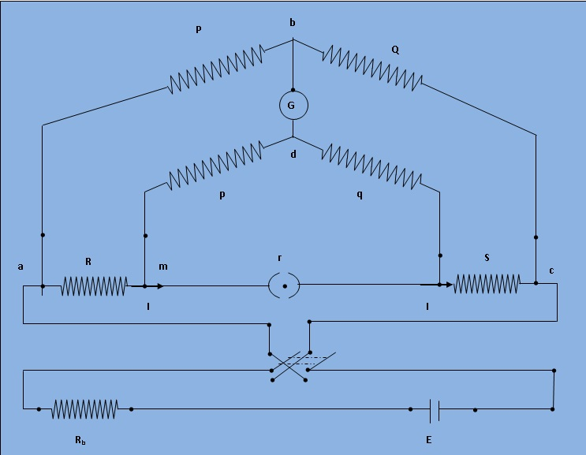  
[Fig 1: Schematic diagram for measurement of low resistance by Kelvin double bridge]

The kelvin double bridge incorporates the idea of a second set of ratio arms - hence the name double bridge- and the use of four terminal resistors for the low resistance arms. Figure 1 shows the schematic diagram of kelvin bridge. The first ratio arms is P and Q. The second set of ratio arms p and q is used to connect the galvanometer to a point d at the appropriate potential between points m and n to eliminate the effect of connecting lead resistance r between the unknown resistance R and the standard resistance S.

The ratio p/q is made equal to P/Q. Under balance conditions there is no current through the galvanometer which means that the voltage drop between a and b, Eab is equal to voltage drops Eamd between a and c.

`E_(ab) = P* E_(ac)/(P+Q)` and `E_(ac) = I*{R + S + r*(p + q)/(p+q+r)}`

`E_(amd)= I*{R+(p/(p+q))*(r*(p+q)/(p+q+r))} = I*(R+pr/(p+q+r))`

for zero galvanometer deflection, Eab=Eamd

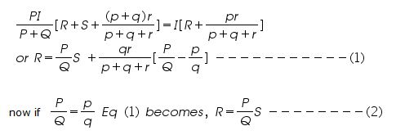

Eq (2) is the usual working equation for the kelvin bridge. It indicates that the resistance of connecting lead, r, has no effect on the measurement, provided that the two sets of ratio arms have equal ratios.

**Measurement of resistance by Wheatstone bridge**

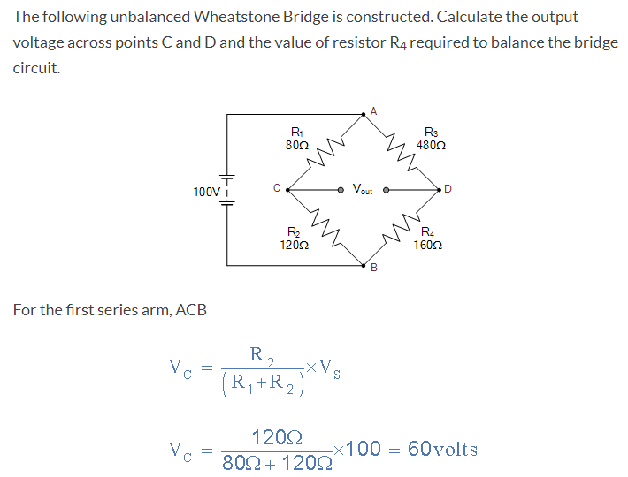

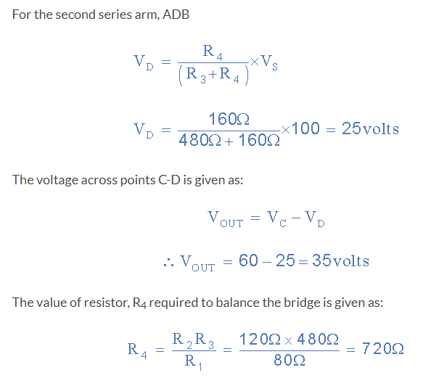

We have seen above that the Wheatstone Bridge has two input terminals (A-B) and two output terminals (C-D). When the bridge is balanced, the voltage across the output terminals is 0 volts. When the bridge is unbalanced, however, the output voltage may be either positive or negative depending upon the direction of unbalance.

**Difference between Wattmeter and Energy Meter**

A **wattmeter** is an electrical measuring device used for measuring the active power in an electric circuit. The wattmeter is a type of **indicating instrument** that means it measure the electrical power in the circuit, only when the current flowing in the circuit.

A typical wattmeter consists of two coils namely **current coil** and **pressure coil**. The current coil of the wattmeter is connected in series with the electrical load, while the pressure coil is connected in parallel with the load. Therefore, the load current flows through the current coil and the load voltage appears across the pressure coil. The load current through the current coil produces a magnetic field which is directly proportional to the current through the coil. This magnetic field can produce a torque in the pressure coil. A pointer is attached to the pressure coil can move over a scale to the show the power reading.

**What is an Energy Meter?**

A type of electrical measuring instrument which measures the total amount of energy consumed by an electrical load over a certain period of time is known as **energy meter**. The energy meter is a type of **integrating instrument** as it maintains the record of measurement over a period. In practice, the energy meters are generally calibrated to measure the electrical energy in **kWh (kilo Watt hours).**

An **electromechanical induction type energy meter** consists of a disc made of aluminium mounted on a spindle and is placed between two electromagnets. The speed of rotation of the disc is directly proportional to the power consumed and this power is integrated over a certain period of time by using a counter and gear train mechanism.

Difference between Wattmeter and Energy Meter

The following table highlights all the major differences between a wattmeter and an energy meter −

|  |  |  |
| --- | --- | --- |
| **Basis of Difference** | **Wattmeter** | **Energy Meter** |
| Definition | An electric measuring device which shows reading of the power consumed by a load in the circuit is called wattmeter. | An electrical measuring device that shows the value of electrical energy consumed by a load in a certain period is called energy meter. |
| Circuit symbol |  |  |
| Quantity measured | A wattmeter measures active (or real) power in an electric circuit. | Energy meters measures the total average power consumed over a period, called energy. |
| Types | There are two types of wattmeter namely ‘electrodynamometer type wattmeter’ and ‘induction type wattmeter’. | Types of energy meters are: ‘electromechanical induction type energy meter’, ‘electronic energy meter’ and ‘smart energy meter’. |
| Measuring unit | A typical wattmeter shows the reading of electrical power in watts. | A typical energy meter shows the energy reading in kWh (kilo Watt hours). |
| Major parts | The major parts of a wattmeter are: current coil, pressure coil, damping system, control mechanism, scale and pointer. | The major parts of an energy meter are: current coil, voltage coil, rotating aluminium disc, breaking system, counting mechanism. |
| Instrument type | A wattmeter is an indicating type instrument. | An energy meter is an integrating type instrument. |
| Applications | Wattmeter is used with electrical devices to measure their power ratings and consumption, and also used in labs to perform experiments. | Energy meters are extensively to measure electrical energy consumed for billing and monitoring purposes. |